32) QOS attributes (Important asked in previous exams also)

* **Data rate (throughput)**
* **Error rate (packet loss)**
* **Delay (latency)**
* **Delay variation (jitter)**

These attributes are essential for ensuring predictable service delivery to certain classes or types of traffic, independent of other factors such as other traffic or link conditions.

33) QOS strategies.

• **Reservation**:

* Reservation of "dedicated" resources for a connection (e.g., CS voice, IntServ/RSVP).

• **Differentiation**:

* Prioritization of the use of a shared resource by different connections (e.g., DiffServ).

• **Overprovisioning**:

* Dimensioning of the network such that all offered (or accepted) traffic can be handled.

34) RED VS WRED

RED applies a uniform packet dropping strategy to manage congestion, WRED introduces weighted probabilities to differentiate and manage various types of traffic, thus optimizing network performance and QoS.

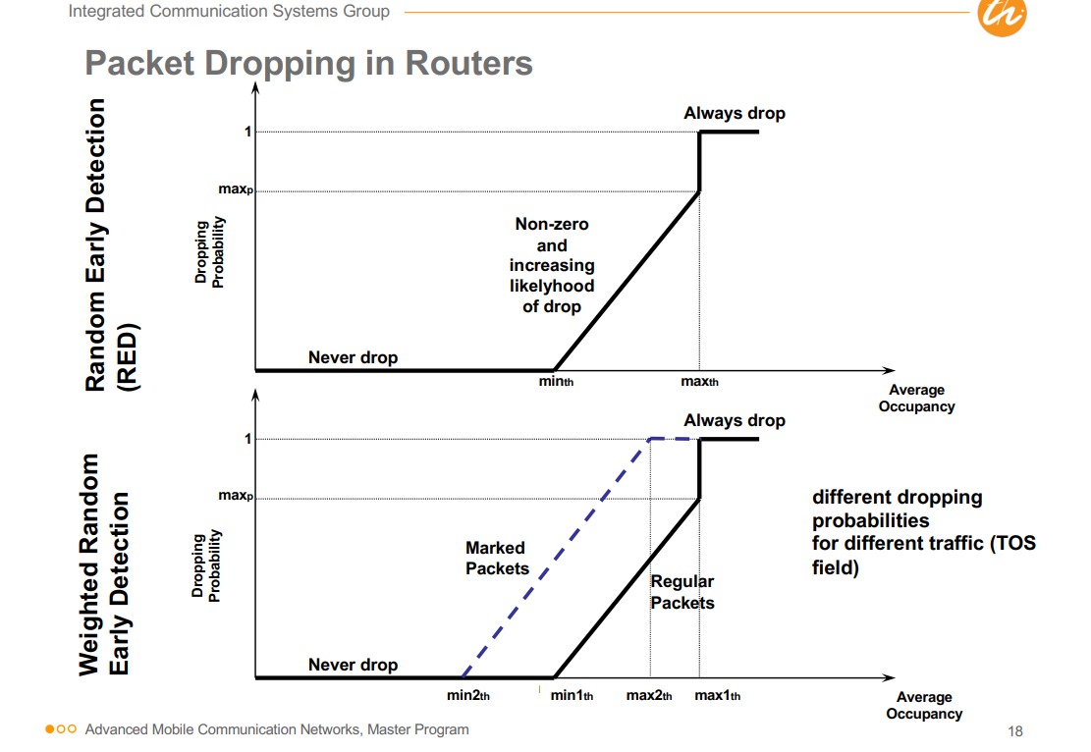

35) mobility management within same IP sub net

If the old as well as the new AP belong to the same subnet, the problem is handled locally in the IP subnet

Link (and PHY) layer mobility management is responsible for the establishment of a radio link between the Mobile Node (MN) and the new Access Point (AP)

36) Diagram of reverse tunneling. Also, prepare diagram of tunneling. Draw CN and MN communication and show reverse tunneling.

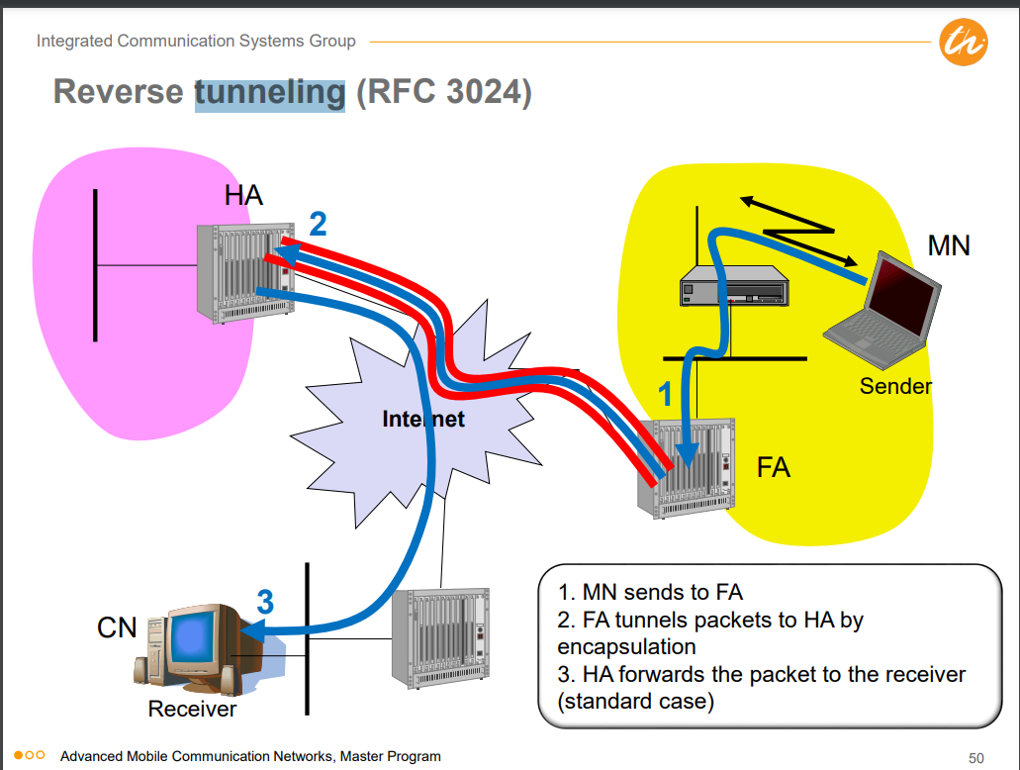

37) PCF DCF

**DCF (Distributed Coordination Function)**

* **Access Method**: DFWMAC-DCF CSMA/CA (Carrier Sense Multiple Access with Collision Avoidance)
* **Traffic Service**: Asynchronous Data Service (mandatory)
* **Collision Avoidance**: Uses a randomized "back-off" mechanism to avoid collisions

### PCF (Point Coordination Function)

* **Traffic Service**: Time-Bounded Service (optional)
* **Access Method**: DFWMAC-PCF
* **Polling Mechanism**: Access point polls terminals according to a list
* **SuperFrame**: Defines time span for polling all wireless stations by AP, including time for responses
* **QoS Limitations**: No QoS guarantees due to unknown transmission durations of polled stations and unpredictable beacon delays

38) TCP ports. Also prepare why different from IP, what are limitations, Pros, cons, when to use.

39) How to determine TCP congestion?

TCP determines congestion primarily by assuming packet loss indicates congestion, which can be problematic in wireless networks due to transmission errors and mobility issues.

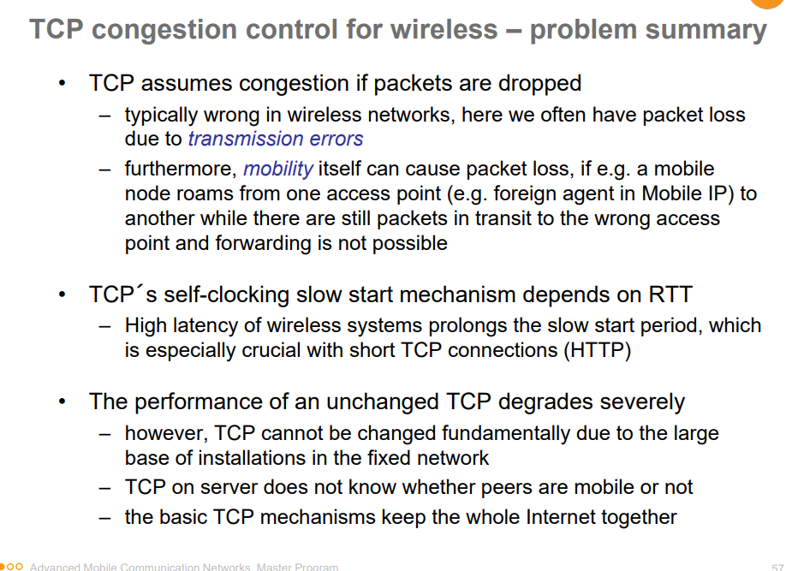

40) Qos of a wireless. (not 100% if this question was given, but I feel so. )

**Wireless Quality of Service (QoS)** refers to the set of techniques and mechanisms designed to ensure the performance and reliability of data transmission over wireless networks.

**QoS Attributes/Requirements:**

* **Data Rate (Throughput)**
* **Error Rate (Packet Loss)**
* **Delay (Latency)**
* **Delay Variation (Jitter)**

41) Geographical greedy based algorithm.

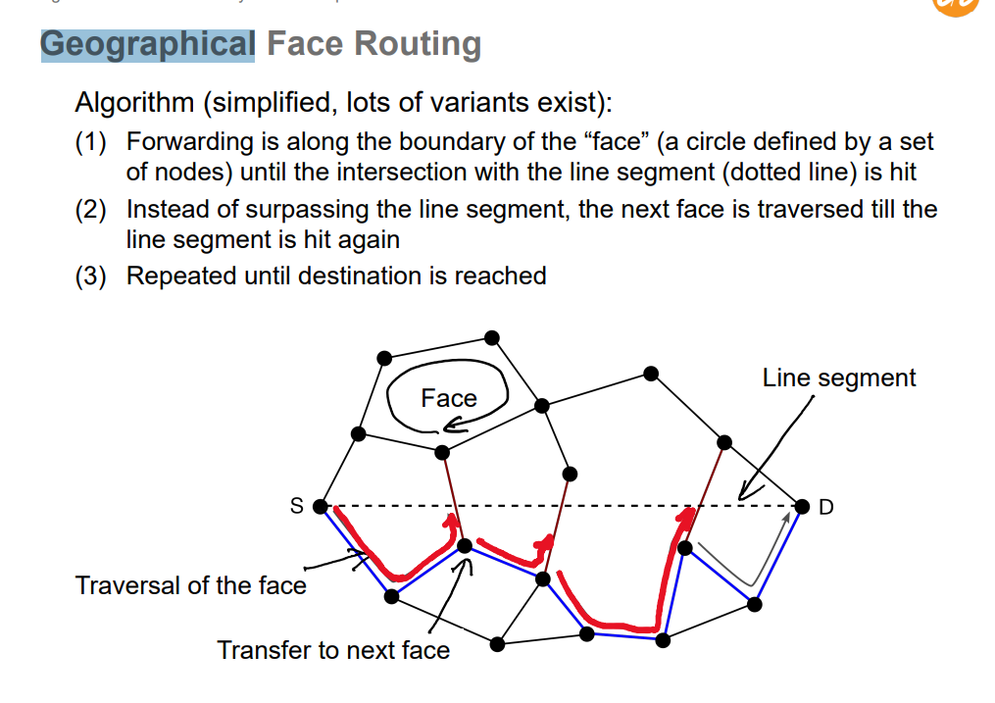

42) Challenges of spectrum sensing.

Secondary user can only sense the primary transmitters, while interference occurs at the primary receiver (hidden-terminal problem)